**Requirements for PO re-balancing**

1. i2 identifies category imbalances on POs and reports (interfaces) these Tuesday through Sunday to SAP (based on the i2 nightly run Monday through Saturday).
2. A subset of Demand Supply Category Peg3 (PEG3) table OR Demand Supply Category Peg4 OR Demand Supply Category Peg3 XUBF OR Demand Supply Category Peg4 XUBF, containing the records matching the following conditions, will be sent to SAP:

* Supply Type = “WIP”
* PR_PO_NBR starting with “4” (Only POs)
* Demand Location IS NOT EQUAL TO Supply Location

1. Whether to use PEG3 or PEG4 table as a source will be configurable via a new table, which will be hosted in i2 database. The table will have an entry per each brand/SBU/DC and it will look like as mentioned below:

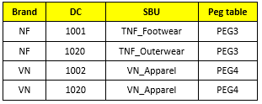

1. The data will be sent out in a flat file format through FTE